

A PROJECT REPORT

ON

ONLINE VOTING SYSTEM

DONE BY

Meetali Mhatre

(EBTSOC0920316861)

Under the Guidance of,

**Mr. V JAYANTH**

**Technical Trainer**

**NASSCOM PROJECT**



**ARISE**

**ONCAMPUS**

**SOFTWARE DEVELOPER TRAINEE**

Tambaram, Chennai-600045 (Tamil Nadu)

2020

**ABSTRACT**

Remote e-Voting is where voting is performed within the voter's sole influence, and is not physically supervised by representatives (e.g., voting from one's personal computer, mobile phone, television via the internet (also called I-voting). Electronic voting technology can speed the counting of ballots and can provide efficiency in statistics. Voting for any social issue is essential for modern democratic societies. So, it is becoming very important to make the voting process easier and more efficient. E-voting should be technically implemented in such a way that ensures adequate user requirements. The proposed system is implemented to allow each and every student to actively participate in the college election process irrespective of the place. This is done by the web application which will accept the votes of different students using the application.

**TABLE OF CONTENT**

**S.**  **TITLE**   **PAGE**

**NO**

ABSTRACT 2

**1. INTRODUCTION TO THE STUDY**

* Introduction 5
* Definition of the Problem 5
* Existing System 5
* Proposed system 6

**2. AIMS & OBJECTIVES OF THE STUDY**

* Objective 7
* Aims 7

**3. LITRATURE REVIEW**  **8**

**4. RESEACH METHOD**  **9**

**5. SYSTEM ANALYSIS**

* Feasibility Study 10
* Technical Feasibility 10
* Operational Feasibility 10

**6. SYSTEM DESIGN**

* Use Case Diagram 11
* Sequence Diagram 12
* Activity Diagram 12

**7. CONCLUSION**  **13**

**8. REFERENCES**  **14**

**APPENDIX-I**  **15**

**SNAPSHOTS**  **15**

**CHAPTER – 1**

**INTRODUCTION TO THE STUDY**

**Introduction:**

"Online Voting System" is a simple web-based online voting system that will help the college to know student's most preferred language for software development. Online voting (also known as e-voting) is voting using electronic systems to aid casting and counting votes. Technological revolutions in computer and communication are enabling the deployment of mobile communication, based on handheld computing devices and wireless networking. Connection capabilities are manifold, and performances of new generation machinery become better and better in terms of computing power and memory size. Their software is able to offer elaborate and complex services, and mobile systems may be exploited for novel applications spread out in a variety of directions. In the past few years, the IT industry has witnessed exponential rise of mobile based and web-based softwares. Such softwares are in demand because they are next to flexible step data access and networking, anytime and anywhere. With operations becoming mobile based one does not have to carry around or depend on PC internet access to perform routine jobs and access online documents and meetings.

**Definition of Problem:**

Online Voting are simple, attractive and ease to use. It reduces manual efforts and bulk of information can be handled easily. But out of all these features there are some drawbacks with this system are, there can be software failure issue, insecure access of internet and also voter should be familiar with internet.

## **Existing System**

The problems of the existing manual system of voting include among others the following:

1. Expensive and Time consuming: The process of collecting data and entering this data into the database takes too much time and is expensive to conduct, for example, time and money is spent in printing data capture forms, and there after advertising the days set for registration process including sensitizing voters on the need for registration, as well as time spent on entering this data to the database.

2. Too much paper work: The process involves too much paper work and paper storage which is difficult as papers become bulky with the population size.

3. Errors during data entry: Errors are part of all human beings; it is very unlikely for humans to be 100 percent efficient in data entry.

4. Loss of registration forms: Some times, registration forms get lost after being filled in with voters’ details, in most cases these are difficult to follow-up and therefore many remain unregistered even though they are interested in exercising their right to vote.

5. Short time provided to view the voter register: This is a very big problem since not all people have free time during the given short period of time to check and update the voter register.

## **Proposed System**

This newly proposed Online Voting System looks forward to eliminate the flaws present in the prevailing system. The proposed Online Voting System, minimizes manual intervention and as a result produces error free, effective and efficient workflow software. The graphical interface makes the project extremely user friendly and is less time consuming. The proposed system will be able to perform many different kinds of important activities automatically including easy report printing and searching of the database.

## **Online Voting System Modules**

**Vote Here:** Register their vote by selecting any one language of their choice and hitting the Submit button. Once done their vote will be registered. One vote per student is allowed.

**Voting Statistics:** Students can see the total number of votes received for each development language.

**Web Service:** Students can see the total entries of votes.

**CHAPTER – 2**

**OBJECTIVES OF THE STUDY**

**Objective:**

Online Voting System developed using Java and MySQL. Online Voting System is a simple web-based online voting system that will help the college to know student's most preferred language for software development. The main feature includes Vote here, Voting Statistics, Web Service.

**Aim:**

The voting process by cell phones gives some decision power to the students, which can actuate directly on decisions of their concerns. The main objective of the system is to develop a web based and android based application to help students to vote for the desired candidates and choose their college representatives in a very easy and efficient manner. The project is implemented to allow each and every student to actively participate in the college election process irrespective of the place.

**CHAPTER – 3**

**LITERATURE REVIEW**

This software is being developed for use by everyone with a simple and self-explanatory GUI. This is software that can be used by people to vote in an election. All the user must do is login and click on his favorable candidates to register his vote. The development and testing is done on Ethernet. While online voting system has been an active area of research in recent years, the use of insecure Internet, well documented cases of incorrect implementations reported recently. These challenges are to be resolved so that public should cast their vote in secure and convenient way. Proposed online voting system is a voting system by which any Voter can use his/her voting rights from anywhere in country.

Online voting system contains:

a) Voter’s information in database.

b) Voter’s Names with username and password.

c) Voter’s vote in a database.

d) Calculation of total number of votes.

Various operational works proposed in the system are: Recording information of the Voter in database.

Checking of information filled by voter.

Discard the false information.

Each information is sent to election commission.

**CHAPTER – 4**

**RESEARCH METHODOLOGY**

The front end of the Online Pharmacy Project contains software such as HTML, CSS, Java script, JSP, JDBC. The back end requires MySQL software to run. IDE eclipse, net beans or my eclipse must be installed. MySQL database is being used. Any IDE can be used for the development of the project, MySQL can be used for database and Apache Tomcat as server.

## **Software Requirements**

* MySQL
* JDK
* Eclipse

## **Hardware Requirements**

* Hard Disk: - 2 GB.
* RAM: - 1 GB.
* Operating system: -Windows 2004/10/64-bit OS, x64-based processor.
* Mouse.
* Keyboard.
* Monitor

## **Technologies Used**

* Java
* MySQL
* JSP
* JavaScript

**CHAPTER – 5**

**SYSTEM ANALYSIS**

**Feasibility Study**

A feasibility analysis involves a detailed assessment of the need, value and practicality of a proposed enterprise, such as systems development. The process of designing and implementing record keeping systems has significant accountability and resource implications for an organization. Feasibility analysis will help you make informed and transparent decisions at crucial points during the developmental process to determine whether it is operationally, economically and technically realistic to proceed with a particular course of action. Most feasibility studies are distinguished for both users and analysts. First, the study often presupposes that when the feasibility document is being prepared, the analyst is in a position to evaluate solutions. Second, most studies tend to overlook the confusion inherent in system development – the constraints and the assumed attitudes.

**Operational feasibility**

People are inherently resistant to change, and computers have been known to facilitate change. An estimate should be made of how strong a reaction the user staff is likely to have toward the development of a computerized system. It is common knowledge that computer installations have something to do with turnover, transfers, retraining, and changes in employee job status. Therefore, it is understood that the introduction of a candidate system requires special effort to educate, sell and train the staff on new ways of conducting business.

**Technical feasibility**

Technical feasibility centers around the existing computer system (hardware, software, etc.) and to what extend it can support the proposed addition. For example, if the current computer is operating at 80 per cent capacity – an arbitrary ceiling – then running another application could overload the system or require additional hardware. This involves financial considerations to accommodate technical enhancements. If the budget is a serious constraint, then the project is judged not feasible.

**CHAPTER – 6**

**SYSTEM DESIGN**

**System Design:**

**Use Case Diagram:**

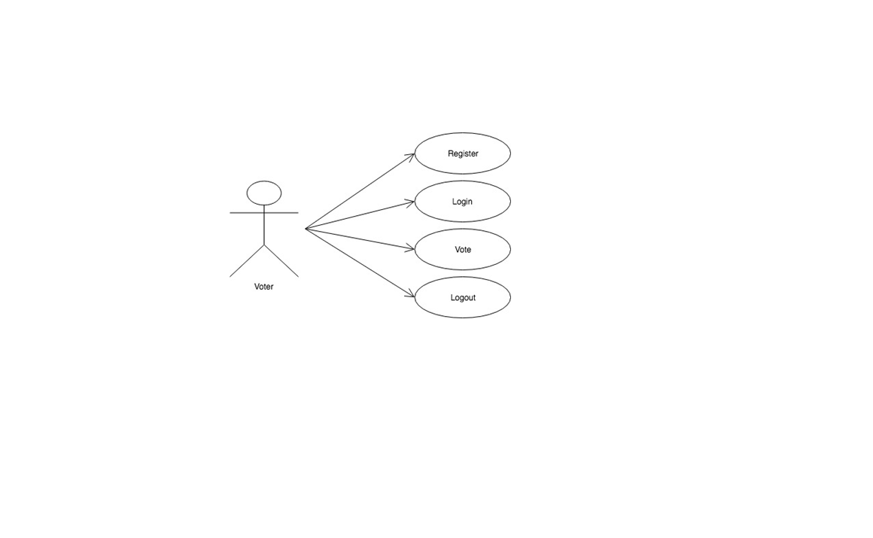

**Sequence Diagram:**

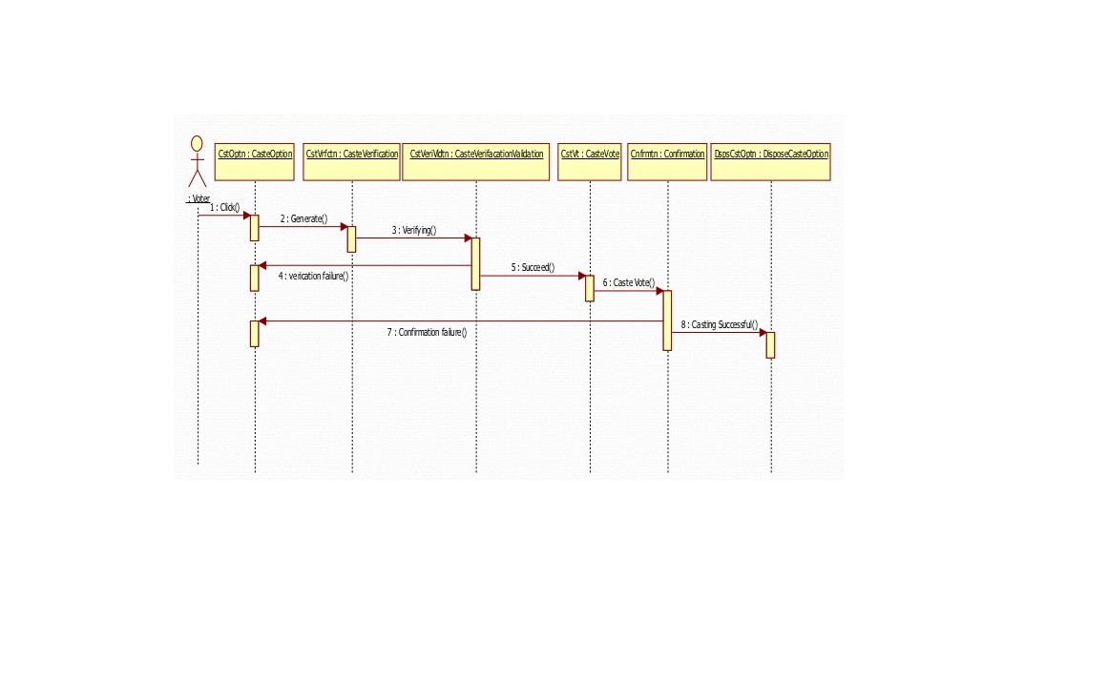

**Activity Diagram:**

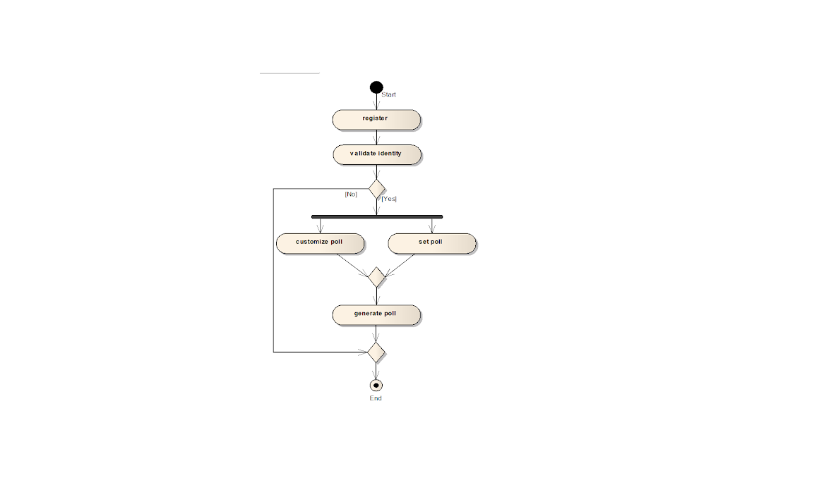

**CONCLUSIONS**

Our proposal enables a voter to cast his/her vote through internet without going to voting booth and additionally registering himself/herself for voting in advance, proxy vote or double voting is not possible, fast to access, highly secure, easy to maintain all information of voting, highly efficient and flexible. Hence, by this voting percentage will increase drastically. The using of online voting has the capability to reduce or remove unwanted human errors. In addition to its reliability, online voting can handle multiple modalities, and provide better scalability for large elections. Online voting is also an excellent mechanism that does not require geographical proximity of the voters.

**REFERENCES**

**[1]** Herbert Scheldt, **Java Complete Reference**, Fifth Edition, Tata McGraw Hill Edition.

**[2]** Phil Hanna, **JSP 2.0**: The Complete Reference, Tata McGraw Hill Edition, 2003.

**[3]** Elmarsi and Navathe, **Fundamentals of Database System** (Third Edition), Addision

Wesley.

**[4]** Ian Somerville, **Software Engineering**, Third Edition, Pearson Education.

**[5]** Ali Bahrami, **Object-Oriented System Development**, Third Edition, Tata McGraw

Hill Edition.

**[6]** Ivan Bayross, **SQL, PL/SQL programming language of Oracle,** Second Edition,

BPB Publication.

**WEB REFERENCES**

**[1] www.google.com**

**[2] www.htmlcodetutorial.com**

**APPENDIX-I**

**SNAPSHOTS:**

1) Login Page:

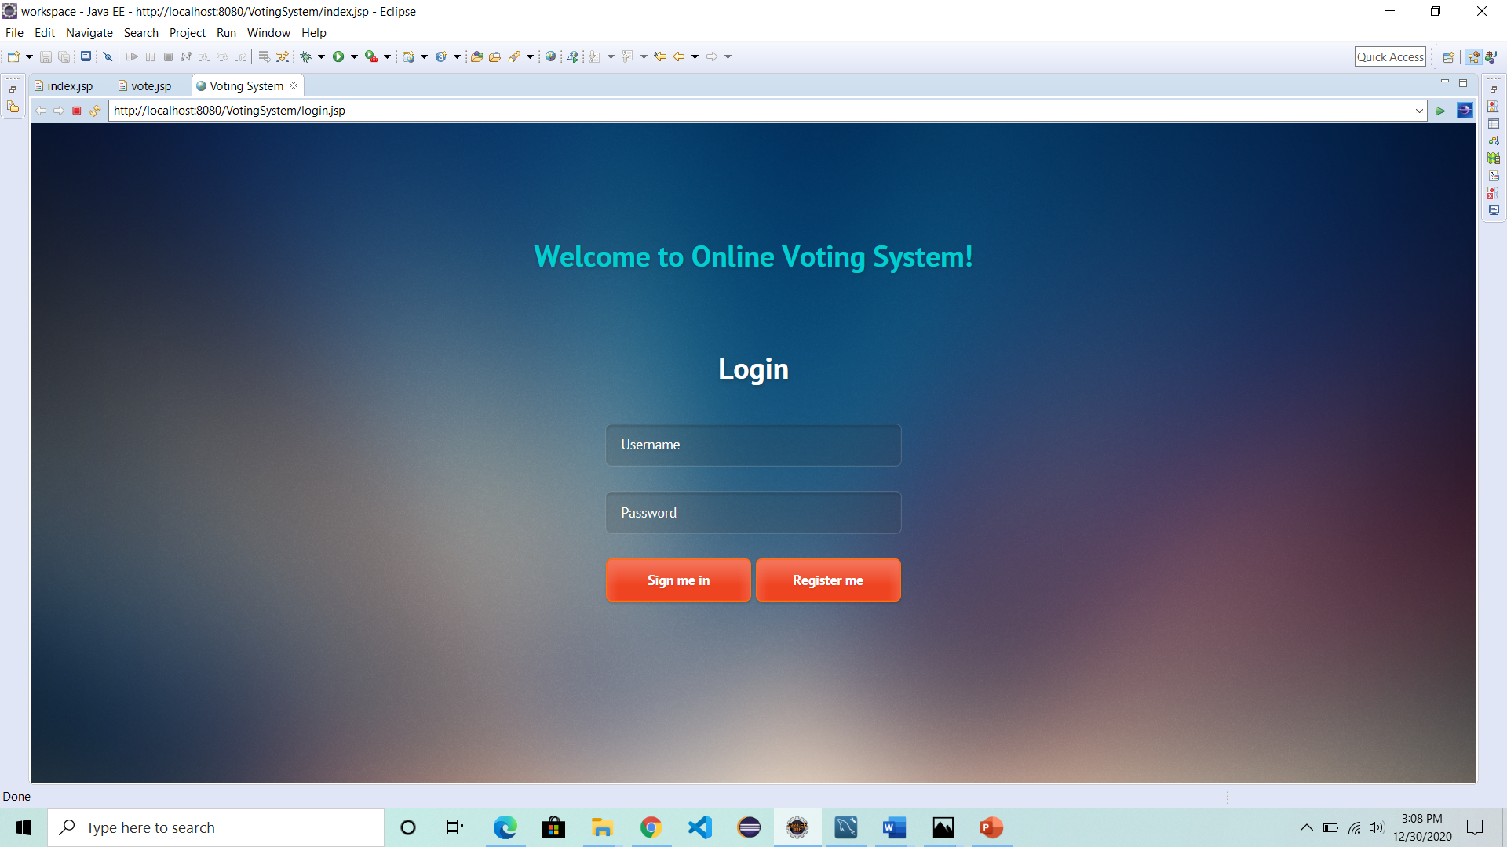

2) Registration Page

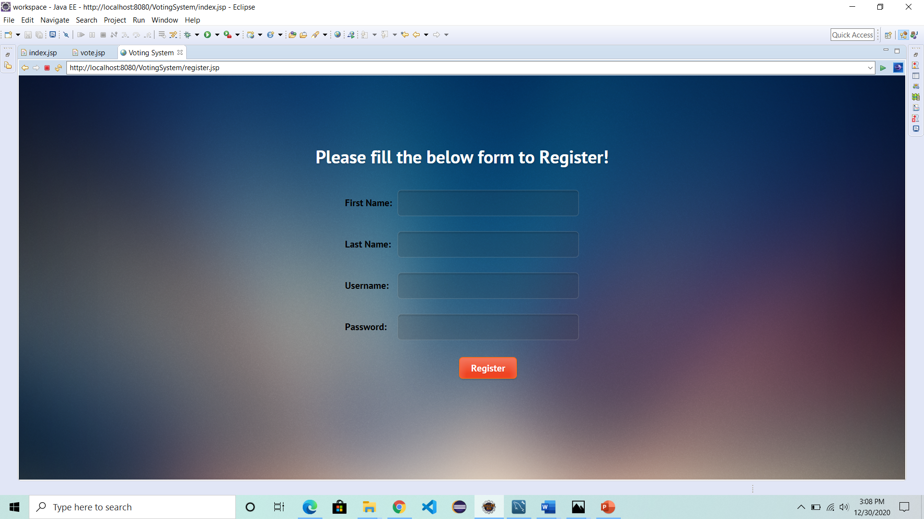

3) Registration Success Page

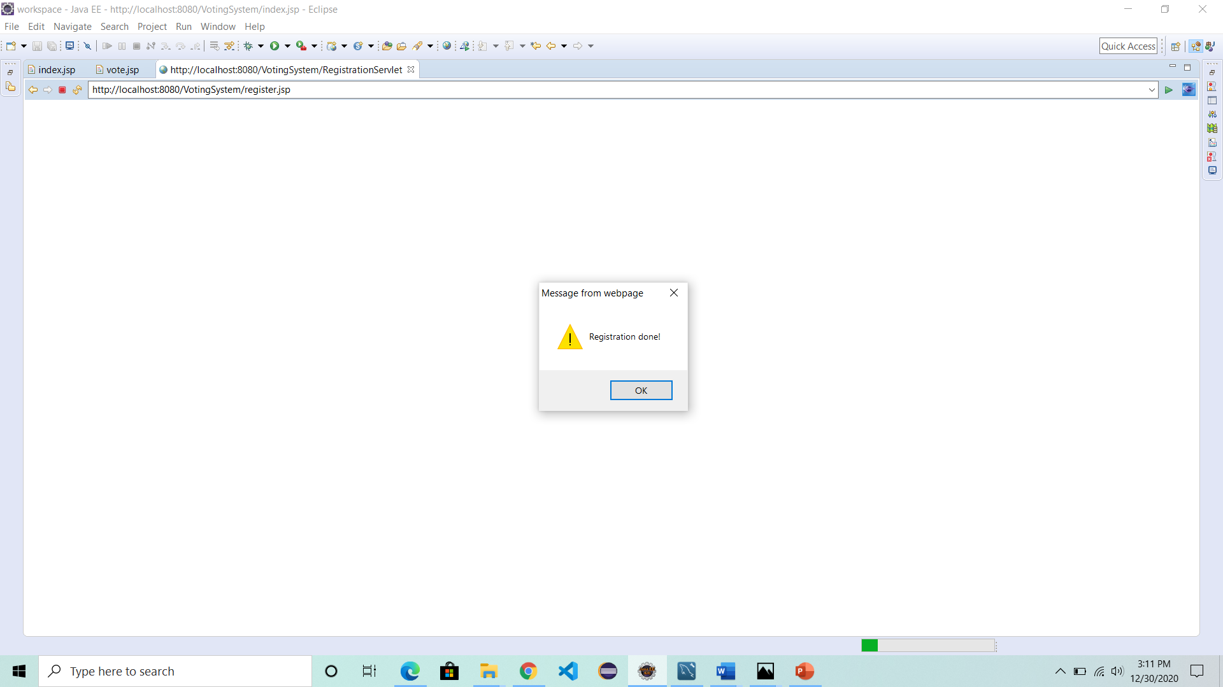

4) Project Description

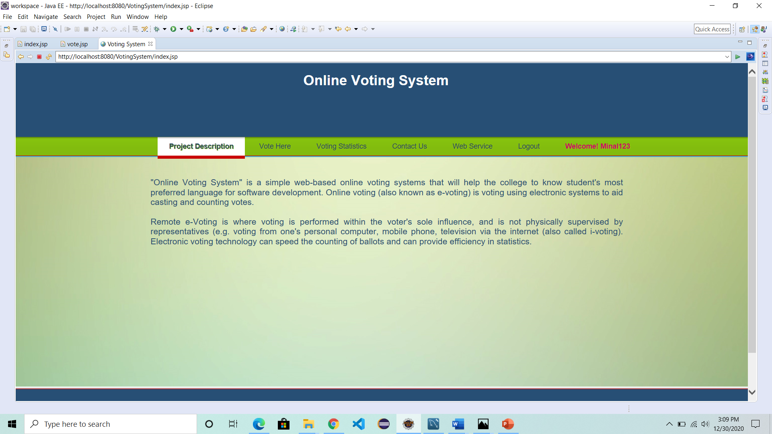

5)Vote Here

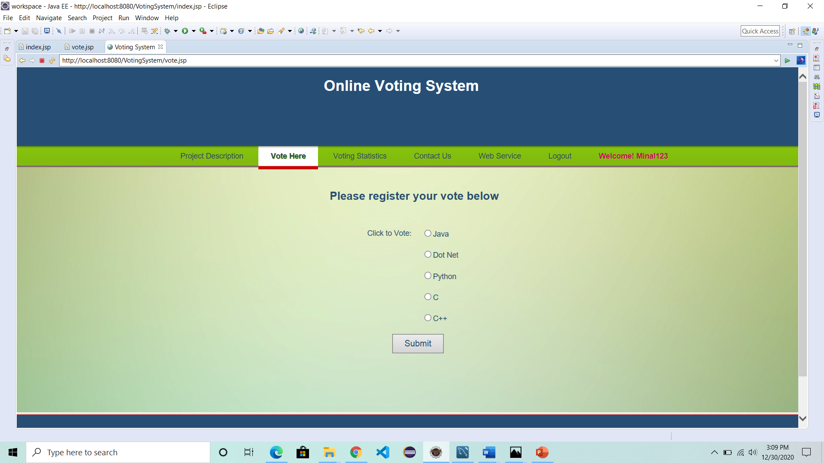

6) Voting Success Page

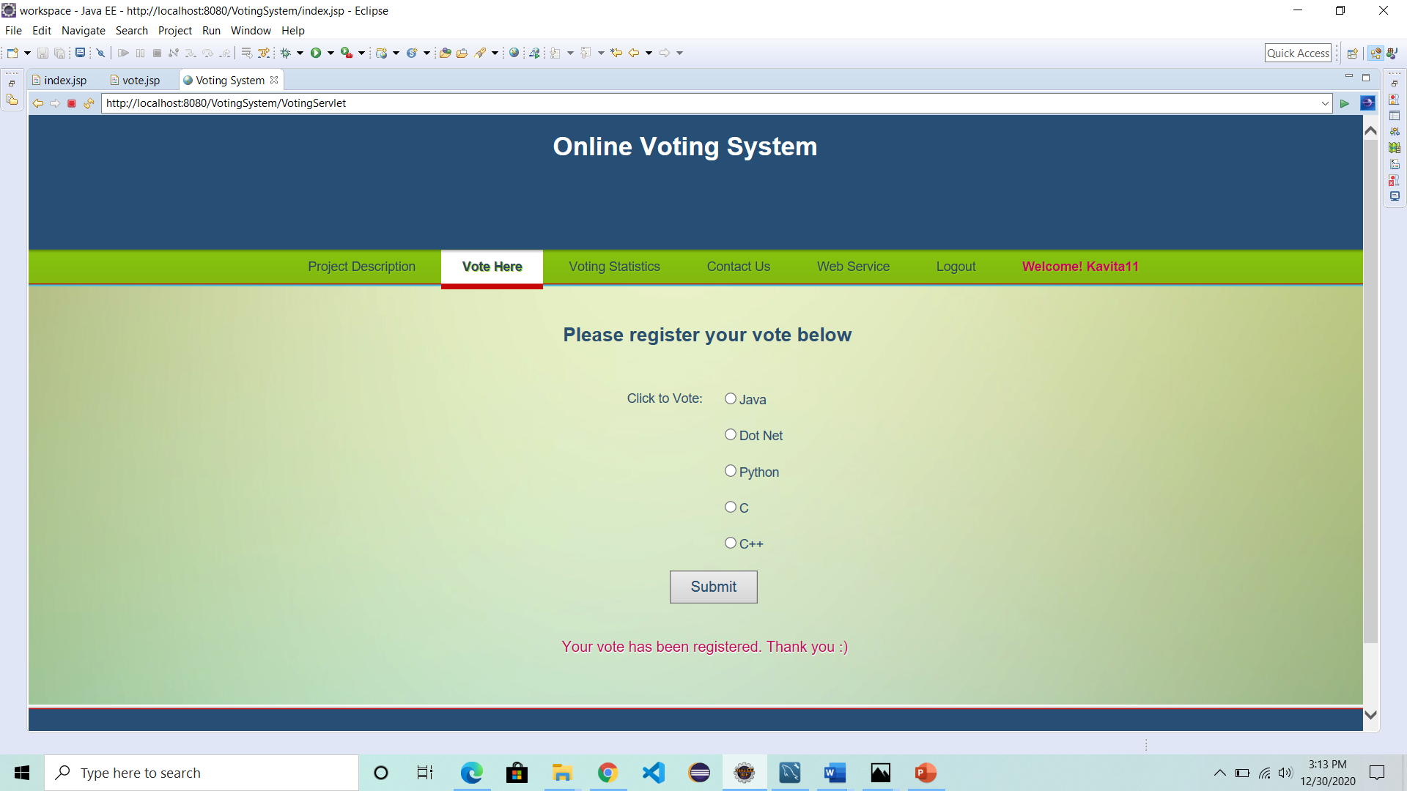

7) Voting Statistics

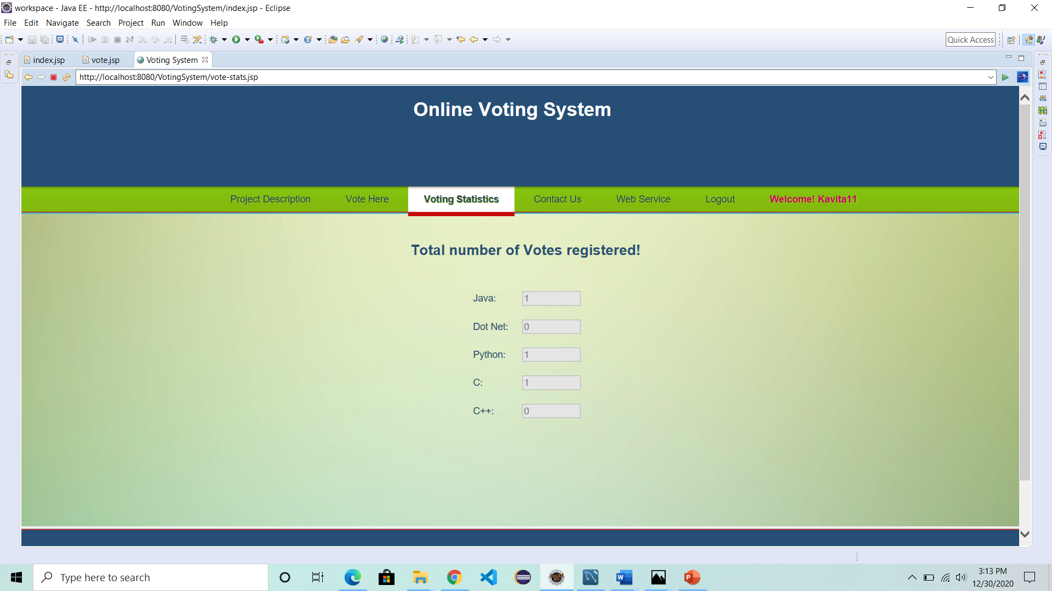

8) Contact Us

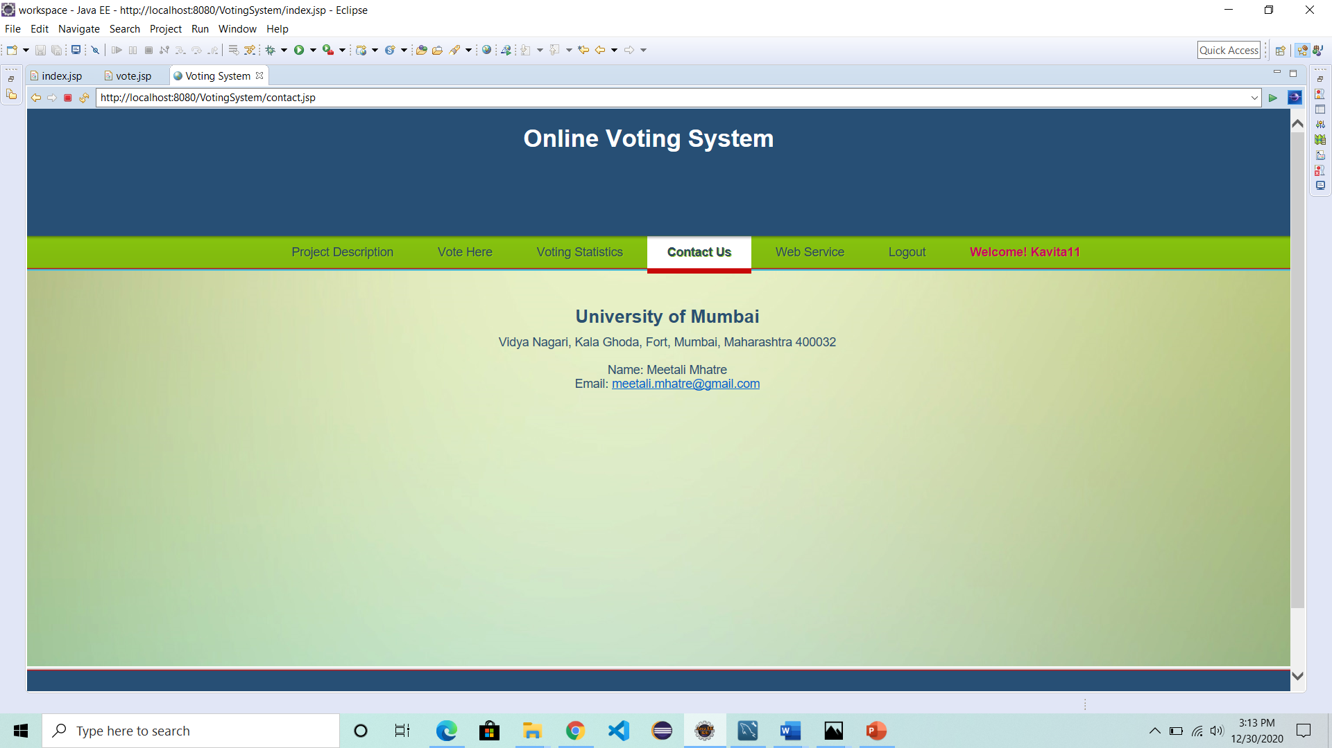

9) Web Service

